Take Assessment - ESwitching Chapter 6 - CCNA Exploration: LAN Switching and Wireless (Version 4.0)

Time Remaining: 

1 | Principio del formulario
  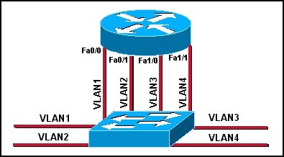
  Refer to the exhibit. Which three statements describe the network design shown in the exhibit? (Choose three.)
   | This design will not scale easily.
   | The router merges the VLANs into a single broadcast domain.
   | This design uses more switch and router ports than are necessary.
   | This design exceeds the maximum number of VLANs that can be attached to a switch.
   | This design requires the use of the ISL or 802.1q protocol on the links between the switch and the router.
   | If the physical interfaces between the switch and router are operational, the devices on the different VLANs can communicate through the router.
2 | Principio del formulario
  What are the steps which must be completed in order to enable inter-VLAN routing using router-on-a-stick?
   | Configure the physical interfaces on the router and enable a routing protocol.
   | Create the VLANs on the router and define the port membership assignments on the switch.
   | Create the VLANs on the switch to include port membership assignment and enable a routing protocol on the router.
   | Create the VLANs on the switch to include port membership assignment and configure subinterfaces on the router matching the VLANs.

3 | Principio del formulario
  Which three elements must be used when configuring a router interface for VLAN trunking? (Choose three.)
  one subinterface per VLAN
  one physical interface for each subinterface
  one IP network or subnetwork for each subinterface
  one trunked link per VLAN
  a management domain for each subinterface
  a compatible trunking protocol encapsulation for each subinterface
4 | Principio del formulario
  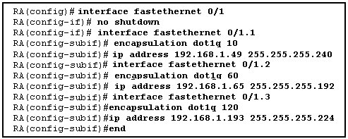
  Refer to the exhibit. The commands for a router to connect to a trunked uplink are shown in the exhibit. A packet is received from IP address 192.168.1.54. The packet destination address is 192.168.1.120. What will the router do with this packet?
  The router will forward the packet out interface FastEthernet 0/1.1 tagged for VLAN 10.
  The router will forward the packet out interface FastEthernet 0/1.2 tagged for VLAN 60.
  The router will forward the packet out interface FastEthernet 0/1.3 tagged for VLAN 120.
  The router will not process the packet since the source and destination are on the same subnet.
  The router will drop the packet since no network that includes the source address is attached to the router.

5 | Principio del formulario
  What is important to consider while configuring the subinterfaces of a router when implementing inter-VLAN routing?
  The physical interface must have an IP address configured.
  The subinterface numbers must match the VLAN ID number.
  The no shutdown command must be given on each subinterface.
  The IP address of each subinterface must be the default gateway address for each VLAN subnet.
6 | Principio del formulario
  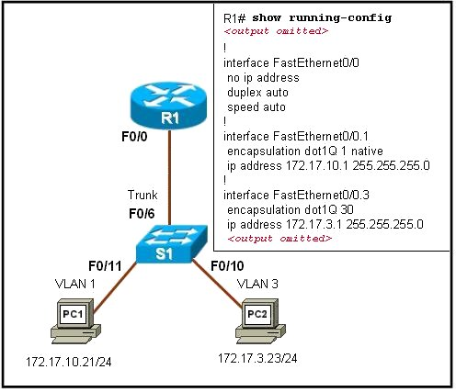
  Refer to the exhibit. PC1 has attempted to ping PC2 but has been unsuccessful. What could account for this failure?
  PC1 and R1 interface F0/0.1 are on different subnets.
  The encapsulation is missing on the R1 interface F0/0.
  An IP address has not been assigned to the R1 physical interface.
  The encapsulation command on the R1 F0/0.3 interface is incorrect.

7 | Principio del formulario
  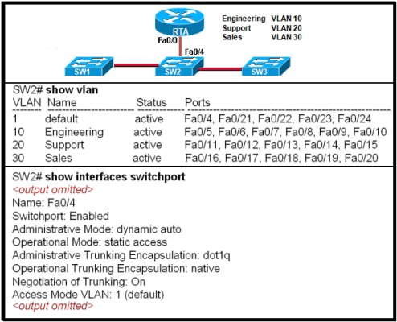
  Refer to the exhibit. The network administrator correctly configures RTA to perform inter-VLAN routing. The administrator connects RTA to port 0/4 on SW2, but inter-VLAN routing does not work. What could be the possible cause of the problem with the SW2 configuration?
  Port 0/4 is not active.
  Port 0/4 is not a member of VLAN1.
  Port 0/4 is configured in access mode.
  Port 0/4 is using the wrong trunking protocol.
8 | Principio del formulario
  What distinguishes traditional routing from router-on-a-stick?
  Traditional routing is only able to use a single switch interface. Router-on-a-stick can use multiple switch interfaces.
  Traditional routing requires a routing protocol. Router-on-a-stick only needs to route directly connected networks.
  Traditional routing uses one port per logical network. Router-on-a-stick uses subinterfaces to connect multiple logical networks to a single router port.
  Traditional routing uses multiple paths to the router and therefore requires STP. Router-on-a-stick does not provide multiple connections and therefore eliminates the need for STP.

9 | Principio del formulario
  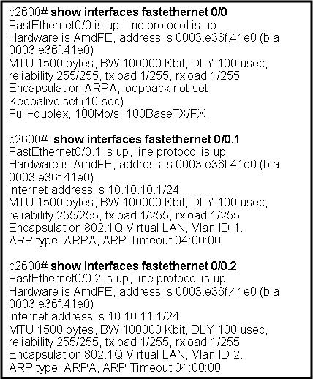
  Refer to the exhibit. Which two statements are true about the operation of the subinterfaces? (Choose two.)
  Incoming traffic that has a VLAN ID of 2 is processed by subinterface fa0/0.2.
  Incoming traffic with VLAN ID 0 is processed by interface fa0/0.
  Subinterfaces use unique MAC addresses by adding the 802.1Q VLAN ID to the hardware address.
  Traffic inbound on this router is processed by different subinterfaces, depending on the VLAN from which the traffic originated.
  Reliability of both subinterfaces is poor because ARP is timing out.
  Both subinterfaces remain up with line protocol up, even if fa0/0 line protocol is down.
10 | Principio del formulario
  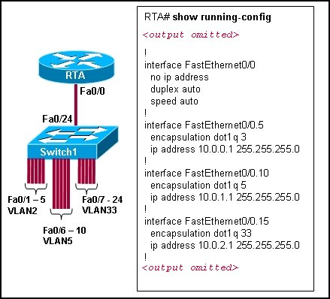
  Refer to the exhibit. Switch1 is correctly configured for the VLANs that are displayed in the graphic. The configuration that is shown was applied to RTA to allow for interVLAN connectivity between hosts attached to Switch1. After testing the network, the administrator logged the following report:
  Hosts within each VLAN can communicate with each other.
  Hosts in VLAN5 and VLAN33 are able to communicate with each other.
  Hosts connected to Fa0/1 through Fa0/5 do not have connectivity to host in other VLANs.
  Why are hosts connected to Fa0/1 through Fa0/5 unable to communicate with hosts in different VLANs?
  The router interface is shut down.
  The VLAN IDs do not match the subinterface numbers.
  All of the subinterface addresses on the router are in the same subnet.
  The router was not configured to forward traffic for VLAN2.
  The physical interface, FastEthernet0/0, was not configured with an IP address.

11 | Principio del formulario
  Which two statements are true about the interface fa0/0.10 command? (Choose two.)
  The command applies VLAN 10 to router interface fa0/0.
  The command is used in the configuration of router-on-a-stick inter-VLAN routing.
  The command configures a subinterface.
  The command configures interface fa0/0 as a trunk link.
  Because the IP address is applied to the physical interface, the command does not include an IP address.
12 | Principio del formulario
  What two statements are true regarding the use of subinterfaces for inter-VLAN routing? (Choose two.)
  subinterfaces have no contention for bandwidth
  more switch ports required than in traditional inter-VLAN routing
  fewer router ports required than in traditional inter-VLAN routing
  simpler Layer 3 troubleshooting than with traditional inter-VLAN routing
  less complex physical connection than in traditional inter-VLAN routing

13 | Principio del formulario
  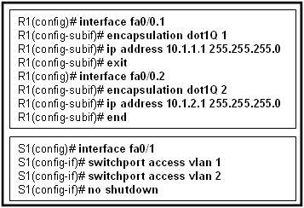
  Refer to the exhibit. Port Fa0/0 on router R1 is connected to port Fa0/1 on switch S1. After the commands shown are entered on both devices, the network administrator determines that the devices on VLAN 2 are unable to ping the devices on VLAN 1. What is the likely problem?
  R1 is configured for router-on-a-stick, but S1 is not configured for trunking.
  R1 does not have the VLANs entered in the VLAN database.
  Spanning Tree Protocol is blocking port Fa0/0 on R1.
  The subinterfaces on R1 have not been brought up with the no shutdown command yet.
14 | Principio del formulario
  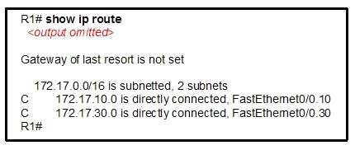
  Refer to the exhibit. What two conclusions can be drawn from the output that is shown? (Choose two.)
  The no shutdown command has not been issued on the FastEthernet 0/0 interface.
  Both of the directly connected routes that are shown will share the same physical interface of the router.
  A routing protocol must be configured on the network in order for the inter-VLAN routing to be successful.
  Inter-VLAN routing between hosts on the 172.16.10.0/24 and 172.16.30.0/24 networks is successful on this network.
  Hosts in this network must be configured with the IP address that is assigned to the router physical interface as their default gateway.

15 | Principio del formulario
  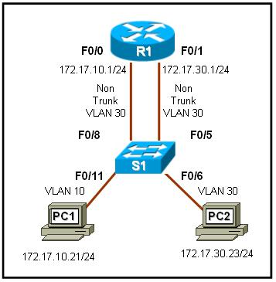
  Refer to the exhibit. All devices are configured as shown in the exhibit. PC2 can successfully ping the F0/0 interface on R1. PC2 cannot ping PC1. What might be the reason for this failure?
  R1 interface F0/1 has not been configured for subinterface operation.
  S1 interface F0/6 needs to be configured for operation in VLAN10.
  S1 interface F0/8 is in the wrong VLAN.
  S1 port F0/6 is not in VLAN10.
16 | Principio del formulario
  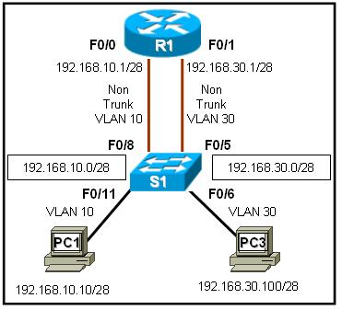
  Refer to the exhibit. R1 is routing between networks 192.168.10.0/28 and 192.168.30.0/28. PC1 can ping R1 interface F0/1, but cannot ping PC3. What is causing this failure?
  PC1 and PC3 are not in the same VLAN.
  The PC3 network address configuration is incorrect.
  The S1 interface F0/11 should be assigned to VLAN30.
  The F0/0 and F0/1 interfaces on R1 must be configured as trunks.
17 | Principio del formulario
  A router has two FastEthernet interfaces and needs to connect to four VLANs in the local network. How can this be accomplished using the fewest number of physical interfaces without unnecessarily decreasing network performance?
  Implement a router-on-a-stick configuration.
  Add a second router to handle the inter-VLAN traffic.
  Use a hub to connect the four VLANS with a FastEthernet interface on the router.
  Interconnect the VLANs via the two additional FastEthernet interfaces.

18 | Principio del formulario
  Devices on the network are connected to a 24-port Layer 2 switch that is configured with VLANs. Switch ports 0/2 to 0/4 are assigned to VLAN 10. Ports 0/5 to 0/8 are assigned to VLAN 20, and ports 0/9 to 0/12 are assigned to VLAN 30. All other ports are assigned to the default VLAN. Which solution allows all VLANs to communicate between each other while minimizing the number of ports necessary to connect the VLANs?
  Configure ports 0/13 to 0/16 with the appropriate IP addresses to perform routing between VLANs.
  Add a router to the topology and configure one FastEthernet interface on the router with multiple subinterfaces for VLANs 1, 10, 20, and 30.
  Obtain a router with multiple LAN interfaces and configure each interface for a separate subnet, thereby allowing communication between VLANs.
  Obtain a Layer 3 switch and configure a trunk link between the switch and router, and configure the router physical interface with an IP address on the native VLAN.
19 | Principio del formulario
  In which situation could individual router physical interfaces be used for InterVLAN routing, instead of a router-on-a-stick configuration?
  a network with high traffic requirements
  a network with a limited number of VLANs
  a network with experienced support personnel
  a network using a router with one LAN interface

20 | Principio del formulario
  Which statement is true about ARP when inter-VLAN routing is being used on the network?
  When router-on-a-stick inter-VLAN routing is in use, each subinterface has a separate MAC address to send in response to ARP requests.
  When VLANs are in use, the switch responds to ARP requests with the MAC address of the port to which the PC is connected.
  When router-on-a-stick inter-VLAN routing is in use, the router returns the MAC address of the physical interface in response to ARP requests.
  When traditional inter-VLAN routing is in use, devices on all VLANs use the same physical router interface as their source of proxy ARP responses.

